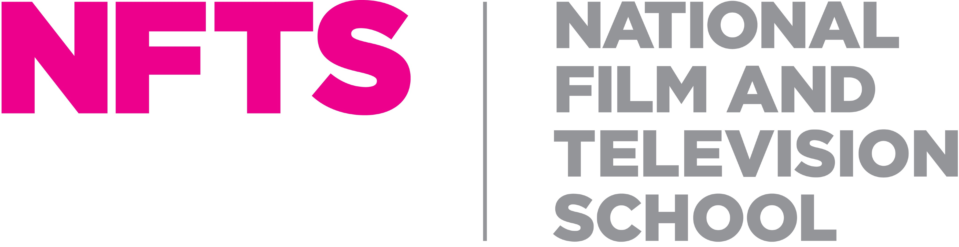

**TUTOR – CAMERA SOUND AND VISION MIXING**

**Location:** NFTS - Beaconsfield

**Contract basis:** approximately 25 days per year as scheduled as course leader and a further 25 days on an ad hoc basis.

**Responsible to**: TV Studio Manager and CSVM Course Leader

**Rate:** £230 per day

The National Film and Television School is an acknowledged global leader in the provision of postgraduate, high-level, creative and technical skills for the audio-visual industries. In just over 50 years the School has established itself as not only one of the world’s best film schools, but as a centre of excellence for television, and games design and development. It was honoured by BAFTA with the 2018 Outstanding British Contribution to Cinema Award, the Queen's Anniversary Prize for Higher Education in 2017, and in 2022 it was granted its own postgraduate Degree Awarding Powers.

We are currently looking for a **Lead Camera Tutor** to provide teaching and support our students on our Camera, Sound and Vision Mixing course. The Lead Camera tutor should be an experienced camera professional with a solid understanding and knowledge of current industry customs and practice. This is a part-time contracted/ freelance role involving approximately 50 to 60 days a year.

Our unique Postgraduate Diploma in Camera, Sound and Vision Mixing aims to prepare participants for a successful future as a camera operator in studio television production, and is run in partnership with Sky, the UK’s largest pay-TV broadcaster.

The role requires good interpersonal skills, tact and patience, together with the ability to recognise and foster potential craft talent, whilst also ensuring students reach the technical standards required of them. Tutors enjoy the experience of observing the students grow and develop their skills and passion for this important role in order to work professionally in the TV industry.

For further information about this role and information on how to apply please visit  <https://www.nfts.co.uk/nfts-jobs>

The closing date for applications will be **Sunday 2nd February 2025**.

*Please note that we are unable to sponsor candidates for this role, so we are only able to accept applications from candidates who are able to demonstrate their right to live and work in the UK.  If you do not have the right to work in the UK, we will not be able to progress your application.*

*At the NFTS, people are at the heart of what we do. We’re an inclusive employer and are committed to equality of opportunity, and building a culturally diverse workforce. We are committed to being an anti-racist organisation and to increasing our representation of staff from Black, Asian and minority ethnic communities. We strongly encourage applications from all backgrounds.*

**JOB DESCRIPTION**

**Purpose of role**:

The lead tutor post requires an experienced Camera professional for television with a solid understanding, knowledge and practical experience of industry customs and practices.

As **Lead** **Camera** **Tutor – CSVM** you will:

|  |  |
| --- | --- |
| 1. | Have had experience working at a senior level in a TV studio as well as on outside broadcasts and/or multi-cam location productions |
| 2. | Show an enthusiasm for passing on knowledge and experience and encouraging students to reach their full potential while inspiring the next generation of television-makers. |
| 3. | Take part in the selection of students to ensure the most talented students secure a place at the NFTS and provide help in developing new exercises for the students |
| 4. | Teach students the very basics of camera rigging and operation to the more demanding multi-cam magazine shows and outside broadcasts and ideally provide some single camera experience (e.g. Sony FS-7 or FX-6) |
| 5. | Monitor the work of each individual camera student and attend discussions to make sure they receive proper analysis of all their work at each stage together with practical recommendations and exercises. |
| 6. | Provide written feedback to the course leader on the students’ progress whenever required to do so. |
| 7. | Demonstrate and impress the importance of professionalism to the students at all times. |
| 8. | Take responsibility for the Health & Safety of the students engaged in workshops reporting any H&S matters arising. |

# PROFILE

This post requires an experienced television professional with solid understanding, knowledge and practical experience of the industry and current practices.

To have demonstrable experience in both single camera and multi camera environments, experience of working in both live and recorded Studio environments

An essential quality is the ability to recognise and foster potential talent, whilst also ensuring students reach the technical and operational standards required of them.

The lead tutor needs to be confident at running camera workshops smoothly and efficiently.

Good interpersonal skills are essential.