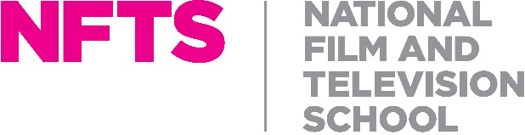

SENIOR TV STUDIO BROADCAST ENGINEER
Full time (35 hours a week), salary in the region of £50,000 per annum, depending on experience
The National Film and Television School (NFTS)
Beaconsfield

JOB DESCRIPTION
Reporting to: HEAD OF ENGINEERING
Purpose of role

The NFTS 4K / HD Television Studio supports multiple disciplines including Directing and Producing Television, Camera, Sound and Vison Mixing courses as well as Script Supervisors and other specialisations including Virtual Production.

The Senior TV Broadcast Studio Engineer is part of a small team that provides engineering support for the Television Studio, the NFTS curriculum, staff and students.

A hands on role, setting up, configuring, operating and repairing equipment in the Television Studio including the implementation and transition to IP protocols including ST2110.

The engineer will support and train students and other staff in the operation of relevant equipment.
Core responsibilities include but are not limited to:
- Setting up, configuring, operating and repairing equipment.
- Support of other Engineers and Trainees across all engineering disciplines.
- The installation, and repair of NFTS equipment and facilities including the planning of routine maintenance and managing reactive maintenance.
- Tuition of students and staff in the operational use of such equipment.
- Day to day operational support in the running of the TV studio as well as to staff and students.
- To work in liaison with other engineering staff on any appropriate engineering projects within the NFTS.
- Any other duties reasonably associated with this post.
Essential
- Detailed knowledge in technical operations and support within a Television Studio environment including live and pre-recorded productions; with the ability to train others in the field and provide hands on support for the school facilities
- A broad knowledge including the ability to perform basic fault diagnosis, repair and operation in other areas of the Film TV production chain
- Ability to successfully manage relationships with a wide range of contacts both internal and external to the school.
- Demonstratable experience of ST2110 and related protocols in a broadcast environment.
- Excellent IT and Networking skills
- Broad knowledge of broadcast technology and software
Relevant field of engineering knowledge for this application
This systems engineer will need specific expertise and experience in
- TV studio operational and engineering
- Live racking of cameras
- Overview of the TV production process
- Planning and installation of AV equipment
- Demonstrable electronic fault finding and maintenance skills – either by a relevant qualification or significant experience
- Wiring

And it would we desirable to have knowledge of some or all of the following:
- Lighting and operation of lighting desks in particular the Grand MA
- HD/4K workflows
- Operation of broadcast audio equipment including desks
- Avid Media Composer/Editshare/Protools
- Adobe creative cloud
- Virtual Production and LED volume experience including Unreal Engine

