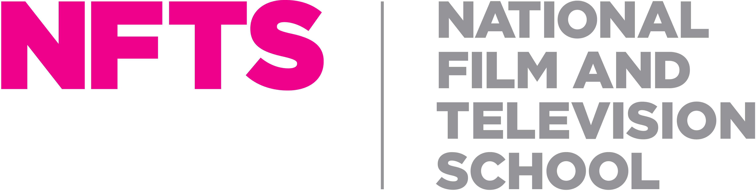

**SENIOR TUTOR – VISUAL EFFECTS (CG)**

**Part time (2 – 5 days a week, negotiable), salary up to £50,000 per annum FTE**

**Fixed term contract, six-month term**

**The National Film and Television School (NFTS), Beaconsfield**

First established in 1971, the National Film and Television School (NFTS) has evolved to become a leading global institution, developing some of Britain and the world’s top creative talent in film, television and games. It is widely acknowledged to be the top school of its kind in the UK and one of the best internationally, being named as one of The Hollywood Reporter’s top international film schools for over a decade. The NFTS is a registered charity (313429).

We are currently recruiting for a **Senior Tutor in Visual Effects (CG)** to support the teaching of our MA in Visual Effects. The NFTS environment provides a blend of technical, artistic and story based training, housed within a working film studio. Our VFX labs are cutting-edge, with dedicated workstations that replicate those used in the VFX industry. Each machine has current industry standard software, including Maya, Unreal Engine, Nuke, Nuke Studio, Photoshop, Substance, Houdini, Resolve, Reality Capture and PTGui.

The Senior Tutor will work closely with the Heads of Department to plan and deliver modules, teaching a significant part of the Visual Effects curriculum. The successful candidate will be an experienced VFX professional, with knowledge and experience of current industry practices. This would suit someone who is excited about imparting their knowledge to, and inspiring the next generation of film and television talent. Flexibility, good oral and written communication skills and the ability to deal effectively with staff and students are essential.

For further information about this role and information on how to apply please visit <https://www.nfts.co.uk/nfts-jobs>.

The closing date for applications will be **Sunday 4th August 2024.**

Please note that we are unable to sponsor candidates for this role, so we are only able to accept applications from candidates who are able to demonstrate their right to live and work in the UK.  If you do not have the right to work in the UK, we will not be able to progress your application.

*At the NFTS, people are at the heart of what we do. We’re an inclusive employer and are committed to equality of opportunity, and building a culturally diverse workforce. We are committed to being an anti-racist organization and to increasing our representation of staff from Black, Asian and minority ethnic communities. We strongly encourage applications from all backgrounds.*

**JOB DESCRIPTION**

**Purpose of role**:

The Senior Tutor – Visual Effects (CG) post requires an experienced visual effects practitioner working in the film and television industry with a solid understanding, knowledge and practical experience of industry customs and practices.

As **Senior Tutor – Visual Effects (CG)** you will:

|  |
| --- |
| 1. Prepare and deliver modules, workshops and teaching days thoroughly with students and fellow tutors, in conjunction with the Head of Department and other members of the VFX team. 2. Teach a significant component of the VFX CG curriculum and oversee the teaching in other specialist areas. 3. Manage and develop the curriculum, in consultation with the specialist tutor in Compositing, including: setting and marking assignments; maintaining and improving existing structures; reviewing students’ progress; pastoral support. |
| 1. Take full responsibility, with support from the Head of Department, for the smooth practical running of a module, workshop, teaching day or production and contribute to its evaluation and future planning when completed. 2. Collaborate with other Heads of Department (e.g. Production Design, Model Making) on shared modules to ensure that students on all courses get a coherent, high-quality experience. |
| 1. Produce module briefs, workshop briefs and descriptions of teaching days, in line with School principles and course learning outcomes. 2. Provide familiarisation for other specialisations that need a basic understanding of the opportunities afforded by Visual Effects, e.g. Directing Fiction and Cinematography. 3. Support NFTS production work which relies upon Visual Effects, advising on approach, workflow and supporting final delivery. |
| 1. Ensure that student assessments and feedback are recorded on relevant forms after all exercises, workshops and projects and that progress reviews are completed at the relevant points in the year. |
| 1. Participate fully in the School's module, workshop, and teaching day evaluation procedures, including preparing and completing all relevant paperwork. |
| 1. Attend any tutor or other meetings relevant to the work you are doing at the School. |
| 1. Engage with continuing professional development of teaching and learning practice. |

**PERSON SPECIFICATION**

* This post requires an experienced visual effects practitioner working in the film and television industry with a solid understanding, knowledge and practical experience of industry customs and practices.
* An in-depth knowledge of and ability to teach at least some of the following: Blender, Maya and Houdini.
* An essential quality is the ability to recognise and foster potential talent, whilst also ensuring students reach the standards required of them.
* You should also have the ability to engage positively with the other departments of the NFTS.
* Senior Tutors are expected to inspire enthusiasm amongst the students and staff for whom they are responsible.
* Good interpersonal skills and excellent communication skills are essential.