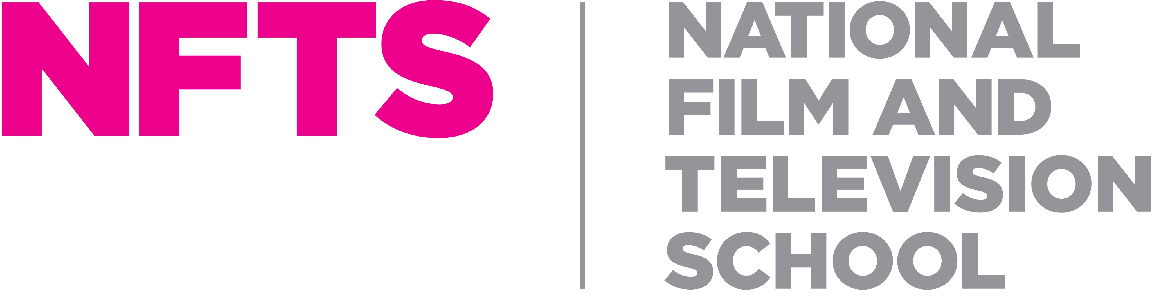

TRAINING COORDINATOR, NFTS WALES - CONTRACT

Closing Date for applications: 6th April 2026

Responsible to: Head of NFTS Cymru Wales
Contract basis: 3 days per week, until 3rd July, and from 24th August to 30th October 2026
Rate: up to £120 per day, dependent on experience
Purpose of the role:
NFTS Wales is looking for a Training Coordinator on a freelance basis primarily to support the BBC | YouTube Create Connect programme, in addition to other NFTS Cymru Wales projects. The ideal candidate will be available to start as soon as possible and should be based in Wales with the ability to commute into central Cardiff at least one day a week. The remaining hours can be worked flexibly.

Application process: To apply for this opportunity, please send a CV and 1-page covering letter to Rhiannon Forsyth, RForsyth@nfts.co.uk, by Monday, 6th April 2026

Core duties and responsibilities include but are not limited to:

- All administrative duties related to the Create x Connect programme
- Raising PO’s and liaising with finance to ensure invoices are sent out and paid in a timely manner
- Booking guest speakers and arranging contracts and payment as required
- Keeping all students fully informed and updated (e.g. course information, homework).
- Creating and distributing training documents and handouts for participants.
- Maintaining accurate planning documents, records and archive of all curriculum activities.
- Book rooms, equipment, transport, travel and accommodation as required and administer associated paperwork and communications.
- Help make sure training rooms, in various in-person venues and online, are tidy and properly set-up
- Providing ad-hoc tutor support where required and supporting the Lead Tutor, Anna Cronin.
- Attend in-house training where required.
- Administer course monitoring and evaluation
- Work alongside the Development Manager where required to ensure the smooth running of other NFTS Cymru Wales projects.
- Contribute to ensuring that the quality of the student experience attending the Create x Connect programme starts and remains high and that outcomes remain consistent with those of a world-leading film, TV and games school.
- Processing bursaries for the NFTS | Prime Video Reskill Upskill programme.
- Undertaking any other duties as may be reasonably required in the position.

Essential Criteria:

Highly organised with exceptional attention to detail and able to multi-task and prioritise effectively.
Excellent verbal and written communication skills.
An excellent command of English (spelling and grammar)
Computer literate, with general knowledge in Canva, Excel, Word, PowerPoint and Outlook
Good knowledge and ability to use of a range of IT programmes and platforms including Google Calendar, Zoom, Eventbrite and Survey Monkey.
Excellent time management skills
Ability to work under pressure
Reasonable level of knowledge experience and skill with technical equipment for film and TV so that curriculum workshops and sessions will have technical support if required by visiting guests and tutors.

Person Specification:

A passion for film, TV and/or digital content
Enthusiastic, proactive and hard-working
Bright and self-motivated, with the ability to use your own initiative whilst also sharing information with your manager and the rest of the team
Polite, confident and personable, with strong interpersonal and relationship building skills with students and other stakeholders

Able to work occasional evenings and weekends and at events, where necessary
Travel may be required for the Create x Connect programme – events take place across the UK

At the NFTS, people are at the heart of what we do. We’re an inclusive employer and are committed to equality of opportunity and building a culturally diverse workforce. We are committed to being an anti-racist organisation and to increasing our representation of staff from Black, Asian and minority ethnic communities. We strongly encourage applications from all backgrounds.

