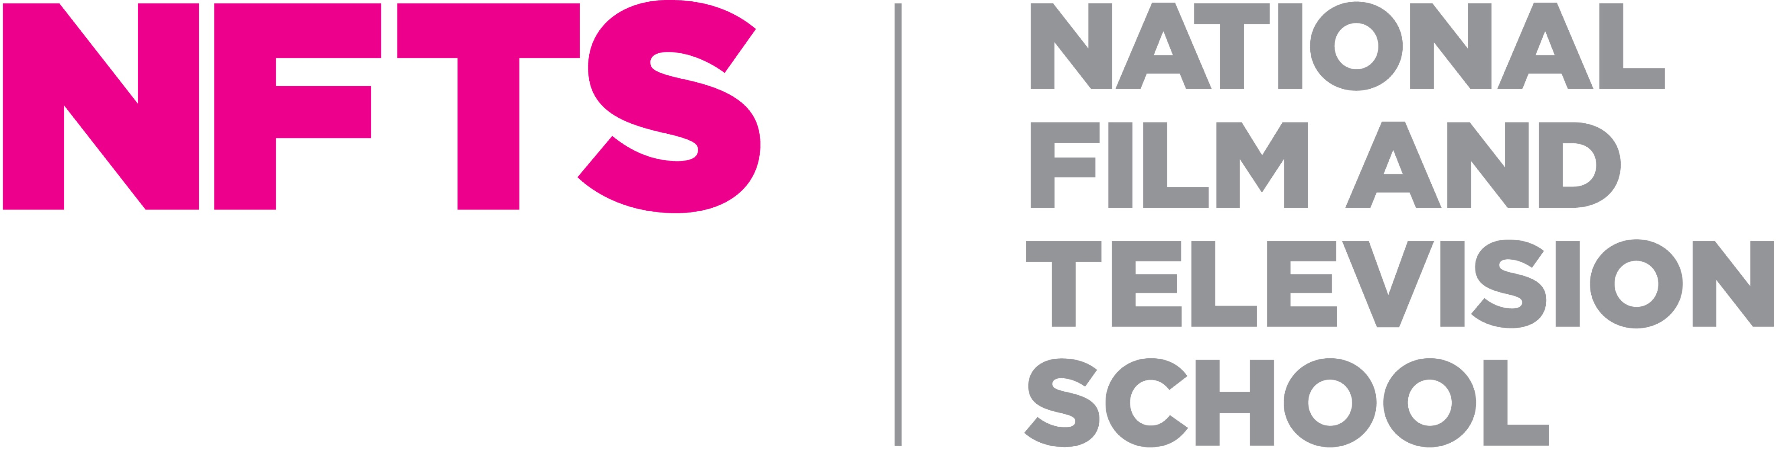

Visiting Tutor – Costume Design

NFTS Beaconsfield/Golden Square and some online guest options available

Responsible to: Head of Department – Costume Design

First established in 1971, the National Film and Television School (NFTS) has evolved into one of the world's leading institutions for film, television and games. Consistently named by The Hollywood Reporter as one of the top international film schools, the NFTS is the UK's premier training ground for creative talent, and right now, it is in the middle of its most ambitious expansion in its history. The NFTS is a registered charity (313429).

We are now looking for industry practitioners, makers and specialists to join our Visiting Tutor pool for our brand-new Costume Design MFA. We’re looking for those who can offer specialist tutoring from cutting and draping, breakdown/dyeing, milliners, shoemaking, jewellers and more.

We are open to discussion about what you can offer us so please email a short intro, CV/portfolio link, and your areas of expertise to costumedesign@nfts.co.uk.

For further information about this role and information on how to apply please visit https://www.nfts.co.uk/nfts-jobs

The closing date for applications will be Sunday 13th December 2026.

Please note that we are unable to sponsor candidates for this role, so we are only able to accept applications from candidates who are able to demonstrate their right to live and work in the UK. If you do not have the right to work in the UK, we will not be able to progress your application.

At the NFTS, people are at the heart of what we do. We’re an inclusive employer and are committed to equality of opportunity, and building a culturally diverse workforce. We are committed to being an anti-racist organisation and to increasing our representation of staff from Black, Asian and minority ethnic communities. We strongly encourage applications from all backgrounds.

